Performing Simulations
Objective
After completing this lesson, you will be able to use the Simulation feature to analyze costs, times, and bottlenecks in your processes.
Process Simulations
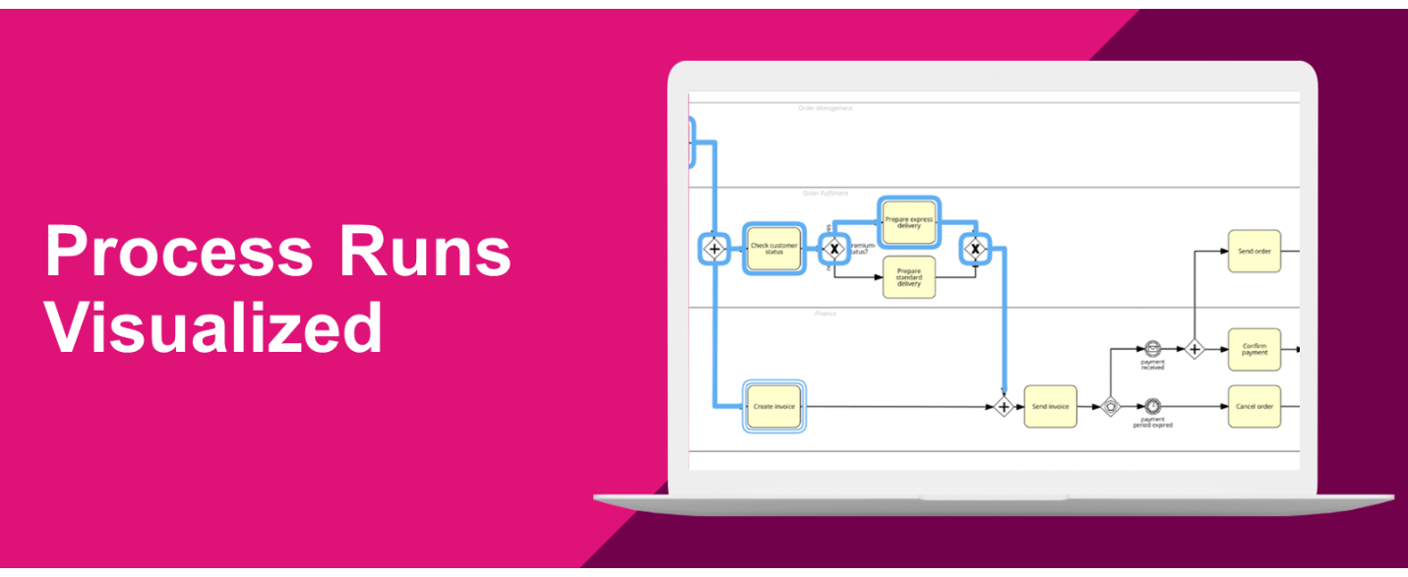
With the simulation feature in SAP Signavio Process Manager, you can conduct simulations of your BPMN 2.0 diagrams using typical process metrics. This allows you to learn more about your processes’ behavior, their average costs and times, as well as their peaks and bottlenecks. There are many reasons for applying process simulation. Check out some of the advantages below:
- Avoid lengthy fine-tuning and expensive testing by easily localizing weak points and bottlenecks.
- Improve existing operations by reducing both cycle and idle times.
- Evaluate alternative concepts, modified process variants, and capacity expansions.
Simulation Options
The Process Manager offers different ways to visualize process runs. You can follow them step-by-step, simulate a single case, or analyze multiple at once. Furthermore, you can create To-Be versions of your process model and compare them with its current state. Before we discuss the attribute data required for simulations, watch the following video to get a better idea of how these features work.
Simulation Parameters
As you have just seen, there are four important tabs in the Scenario window: Costs, Duration, Frequency, and Resources. With a simple Order-to-Cash process as our example, we’ll take a closer look at each one of them now. As we go through the sections, you’ll understand how the different components of the simulation feature can help you make informed decisions.
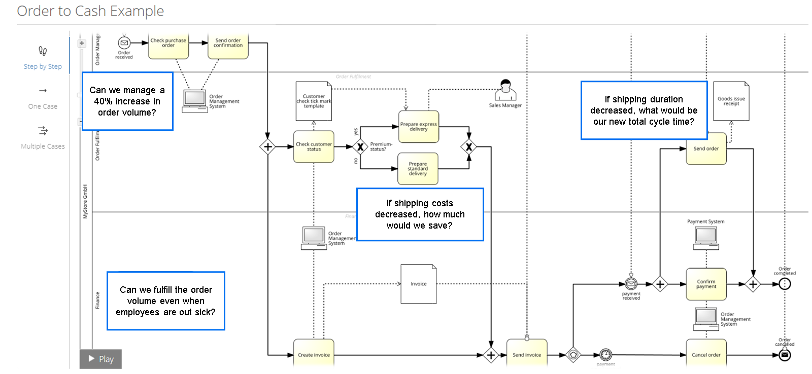
Costs
Typical question: If shipping costs decreased, how much would we save?
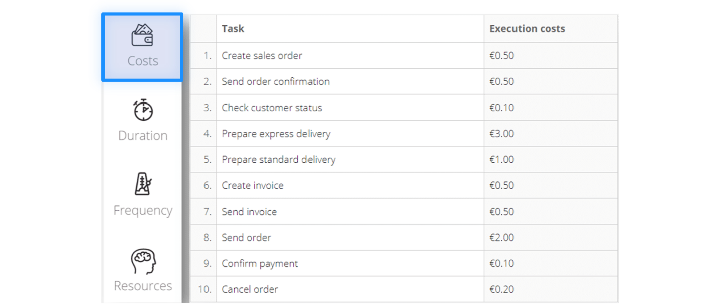
In order to calculate the overall process cost, you need to provide the executions costs for each activity first. These can comprise material, electricity, and other task-specific expenses. Don’t include the labor costs here, as they are set up under the Resources category. To simulate any changes, simply decrease or increase the amounts.
Hint
The currency used in your processes can be configured in the workspace settings by the administrator.
Duration
Typical question: If shipping duration decreased, what would be our new total cycle time?
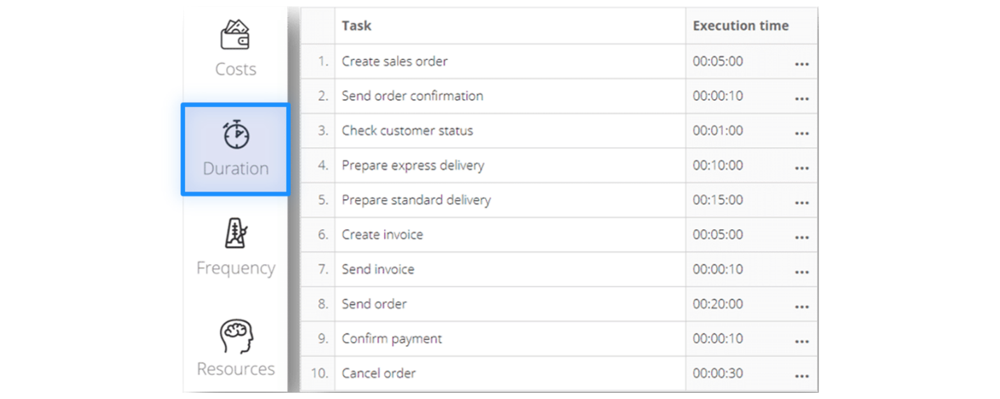
The individual task execution times you provide are used to calculate the total cycle time of a process. Keep in mind that this is most likely only its minimum duration. In practice, the cycle time is usually more than just a sum of execution times. Often, there are waiting times, idle times, and many other factors which impact the process’ duration.
It’s natural that some tasks, especially manual ones, will sometimes take less or more time. To account for that, you can specify the execution times for each activity by clicking on the ellipses next to it. As in the image below, you can define the proportions of cases with a specific duration, as well as the distributions they should follow.
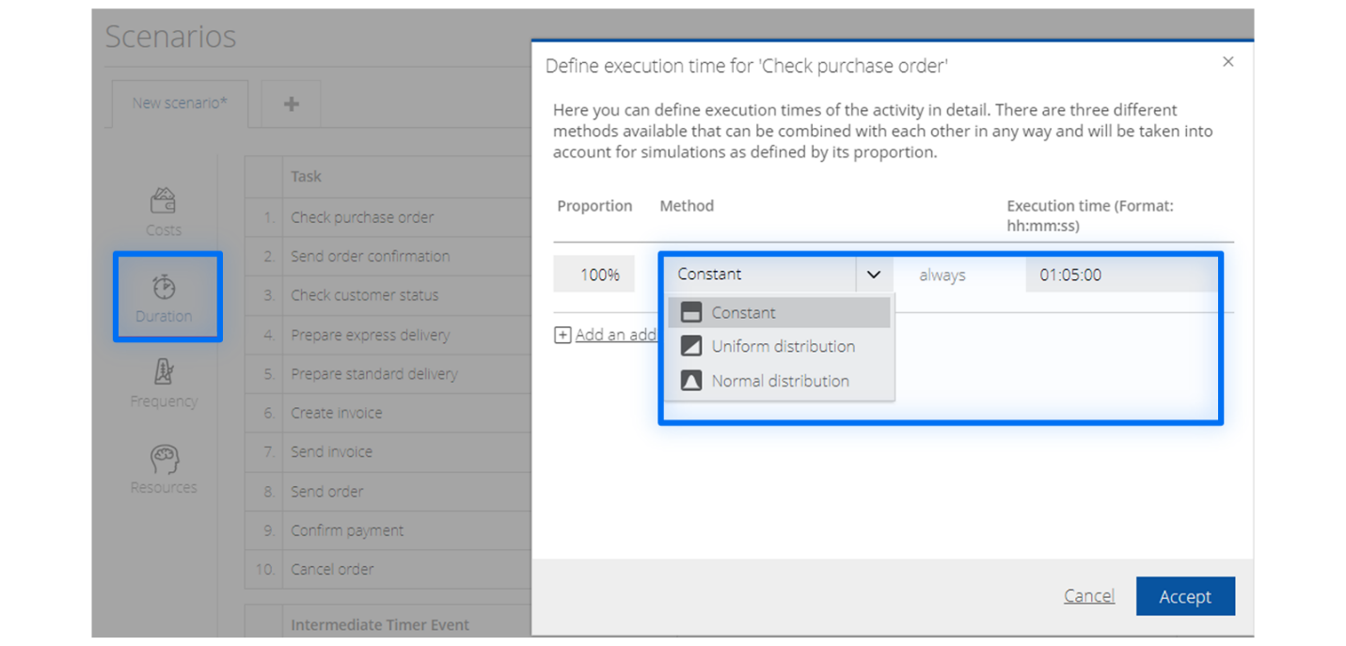
Frequency
Typical question: Can we manage a 40% increase in order volume?
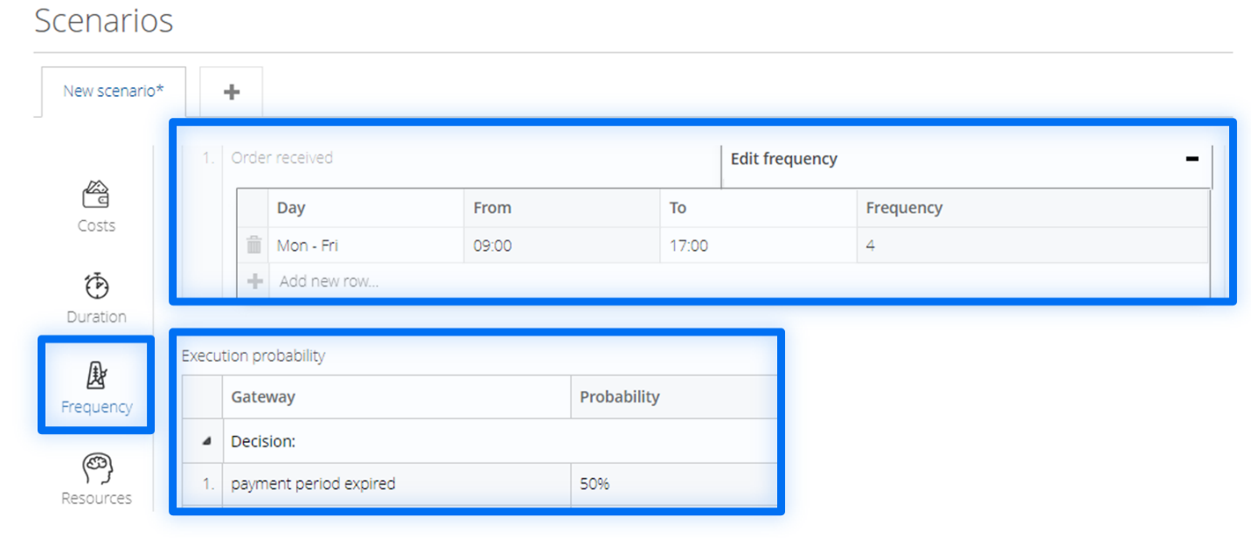
When stimulating multiple cases, you need to define the frequency with which new cases start in a set time frame, for example, throughout the week. This can be further adjusted to account for differences on specific days or during certain hours. By default, the frequency is set to 4, meaning that we’ll have 4 new cases a day and 20 new cases per week. If we would want to simulate an increase in order volume, we would simply set it to a higher number.
If you used any gateways in your diagram, you also need to define the execution probabilities in the Frequency tab. Every time the process reaches a decision point with various outcomes, these probability estimates will be used to route it accordingly. These are applied independently of the previous cases.
Resources
Typical question: Can we fulfill the order volume even when employees are out sick?
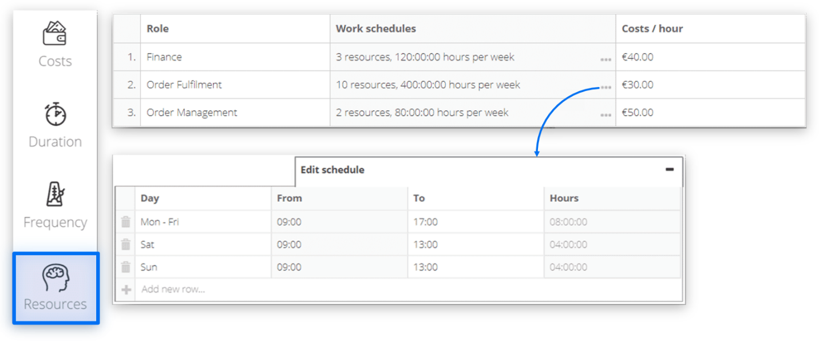
In the Resources tab, you can set up detailed working schedules and specific hourly wages for each lane in your diagram. This information will be used to calculate the overall process cost. Furthermore, the available resources are the most important factor influencing the total cycle time and bottlenecks. The latter might occur due to limited availability. For example, a new case might have already started, but the workers are still occupied handling the previous instance. With the simulation feature, you can identify bottlenecks and thus the areas, where additional resources are needed.
Simulation Results
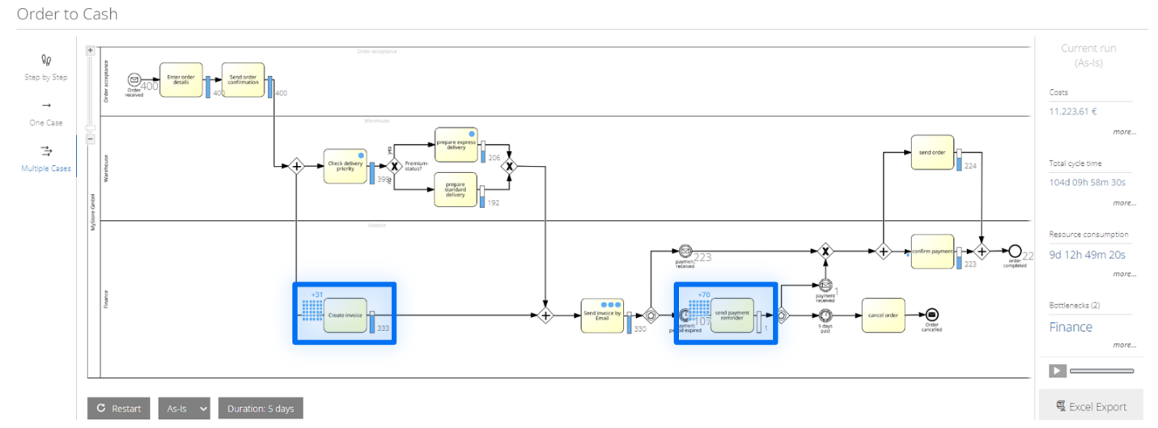
Let's take a quick look at how the process metrics will be displayed once a simulation has been run. In the right panel of the image above the results of a multiple-case simulation are shown. Here's how you can interpret them:
Costs
The sum of fixed activity costs and resource costs. If deviations for activity times have been set, the costs can vary based on execution time.
Total cycle time
The sum of all execution and waiting times. If the total cycle time exceeded the simulation time span, there are two main reasons for this:
- Your resources can't handle new cases fast enough and instances accumulate.
- New cases occurred in the last hours or minutes of the simulation.
Resource Consumption
The sum of the working hours process participants must spend for it to be completed.
Bottlenecks
The lanes in which the bottlenecks take place. The actual waiting times are displayed with blue dots next to the activity in the diagram.

